**CHAPTER-3**

**3.1 INTRODUCTION**

1This hotel management system is developed for hotels those are using a manual system to handle hotel processes. There are three main users in hotel management system, administrator, Manager and Receptionist. Administrator can maintain daily updates in the hotel records. This system will automate the major operations of the hotel. Administrator can access to all system functionalities without any restrictions. Administrator is must be an authorized user. He can further change the password. There is the facility for password recovery, logout etc. Manager can access to all system functionalities with limited restrictions. Receptionist can only access to the Reservation Management section. The main aim of the entire activity is to automate the process of day to day activities of Hotel.

The Reservation System is to keep track in room and hall reservation and check availability. Using this system user can check which room is reserved and which room is available. He can reserve room from reservation module. The Room Management System is for manage all room types room services. Room management module help user to keep track of all information of hotel room. He can check room laundry service, food service and sweeping service from this module. The Inventory Control System will keep track in all inventories of the hotel and guest details will handled by guest management. Administration department will monitor the all. the main of developing this system is to computerize all the activity of the hotel like Admission of a New Customer, Assign a room according to customer’s demand, checkout of a customer and releasing the room and finally compute the bill etc. Using this system you can manage check in and check out process easily. At check in, you can easily check the availability of rooms in the hotel. And at check out you can easily generate the total bill.

The main objective of the entire activity is to automate the process of day to day activities of Hotel. Using this system you can manage room activities and keep track of admission of a New Customer. Using this system you can check rooms according to customer’s need and can assign easily room to customer. Checkout of a customer and updating the releasing room information in the system is very easy. When user do checkout system will generate final bill after calculating all the bills. User can also check online, all the packages available. He can also book rooms online. He can also cancel booked room online. Hotel management can also check the list of Regular customers and feedback of the hotel’s customer.

**3.2 Framework :-**

**Cover Page :-** It includes topic of our mini project and a next button which proceeds to the login page.

**Login Page :-** It includes a Create button which takes you to the new user registration page. Else it contains a login button which matches your username and password you entered in their respective field. The Cancel button can be used to exit the program.

**Dashboard :-** This is the main page of our project which contains Admin and reception dropdown menu.

**Admin :-** The admin section contains Add driver, Add Employee and Add Room options.

**Reception :-** This section contains all the necessary tools for the Receptionist of the Hotel.

**3.3 Algorithm and process design**

Steps to run the project :

* Run the main page of the hotel management system in eclipse.
* After cover page appears, click on next.
* Create a new account or login with an existing account.
* Use the admin section to add new rooms, drivers or employees.
* The Reception section can be used to keep track of all the necessary systems in the Hotel like the customer details, rooms available and all the necessary information.

**3.4 Details of Hardware and Software**

Software Configuration: The project is developed using Java as front end which is supported by Oracle. MySQL is used as back end to store the data in the database. Operating System: Windows 7, 8, 10 / Macintosh / Linux(any distro with a proper setup)

Language: Java Runtime Environment, Eclipse IDE

Database: MySQL

Hardware Configuration: Processor: Intel CORE i3 or greater

Hard disk: Minimum 50GB

Ram: 1 GB or more

**3.5 EXPERIMENT AND RESULT**

**A)COVER PAGE**

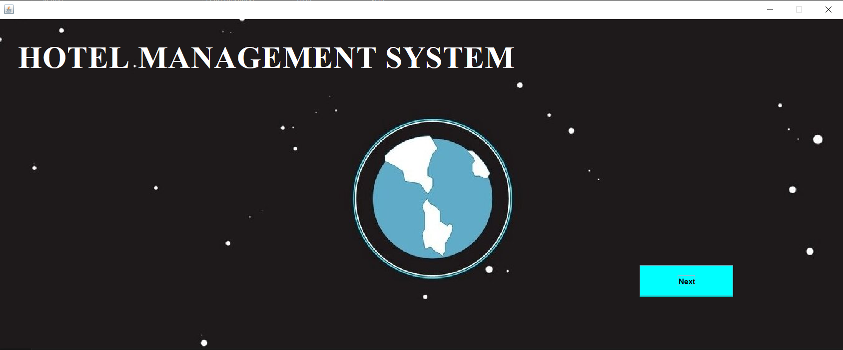

**B) LOGIN PAGE**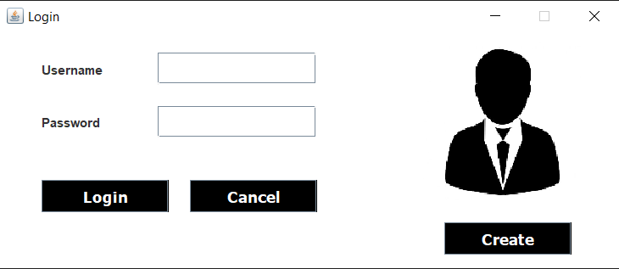



C) **IF A NEW USER REGISTERED THEN HIS ID PAGE**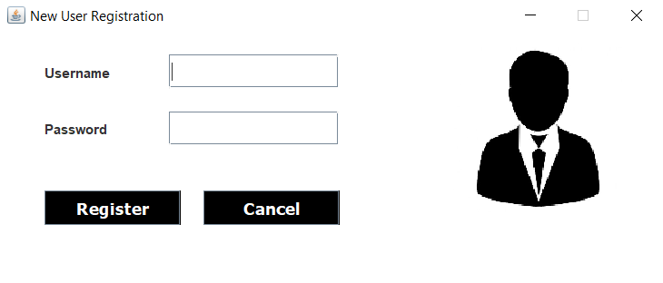

**D)AFTER REGISTERATION IS SUCCESSFULL**

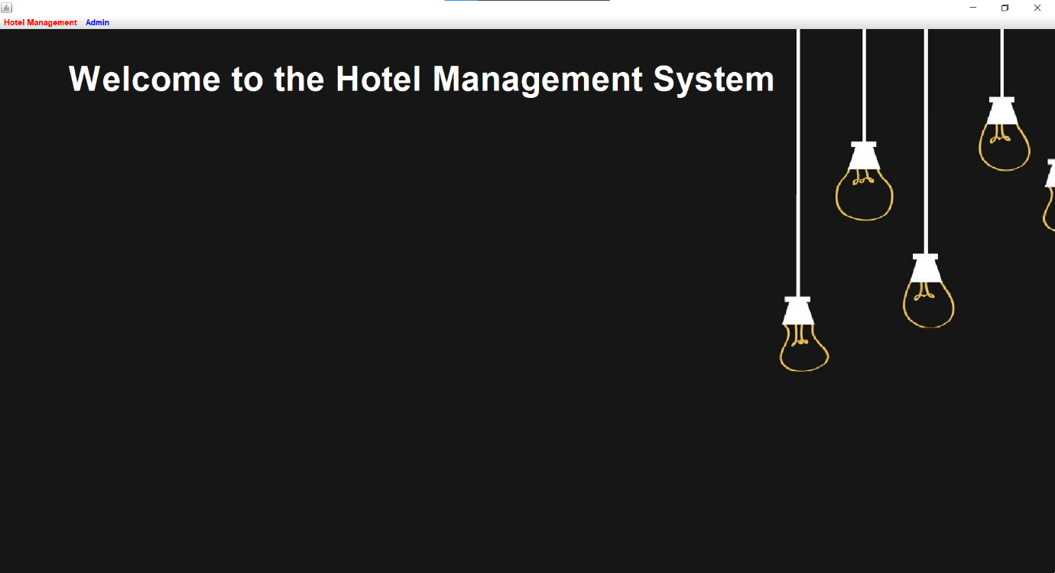

E)ADD EMPLOYEE DETAIL PAGE

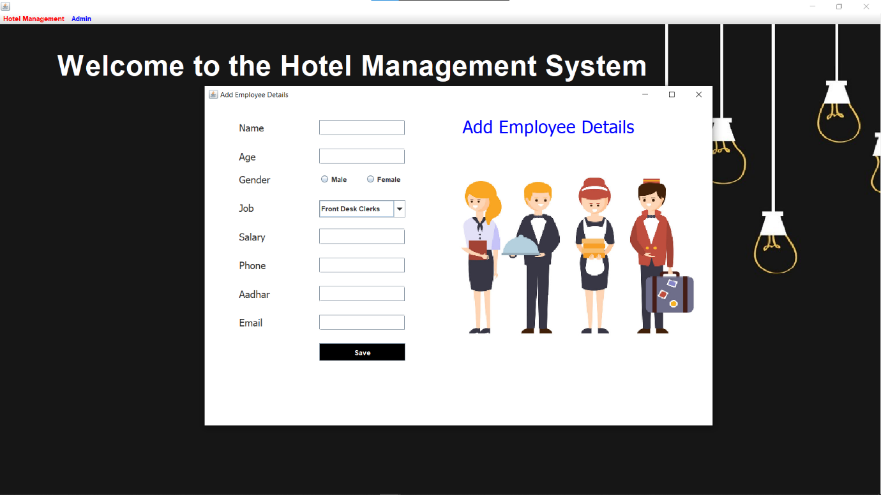

F)UPDATE ROOM STATUS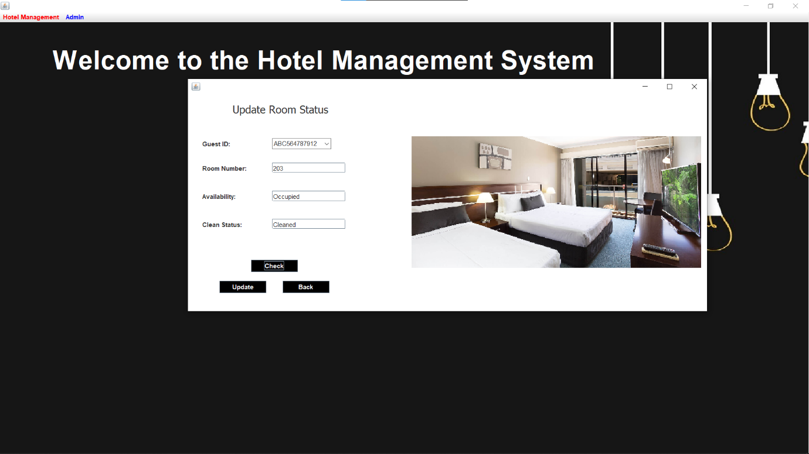G)CHECK IN DETAILS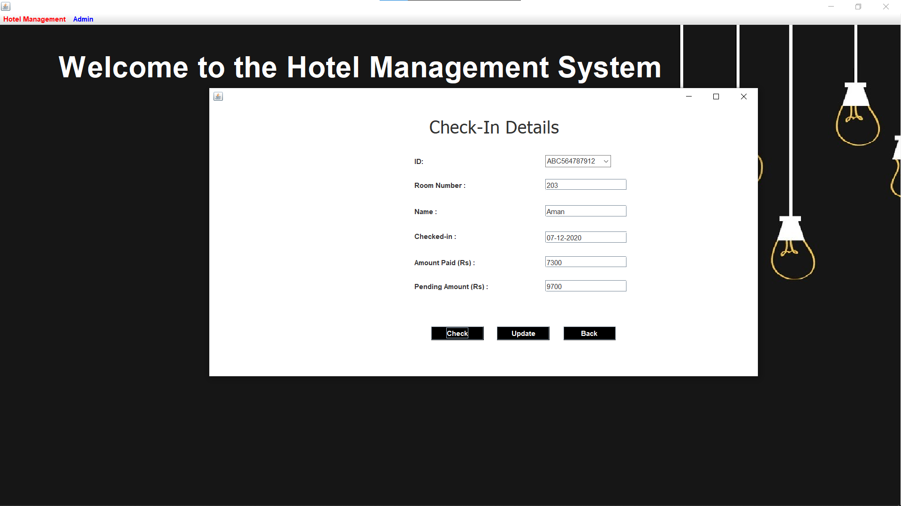H)CHECK OUT DETAILS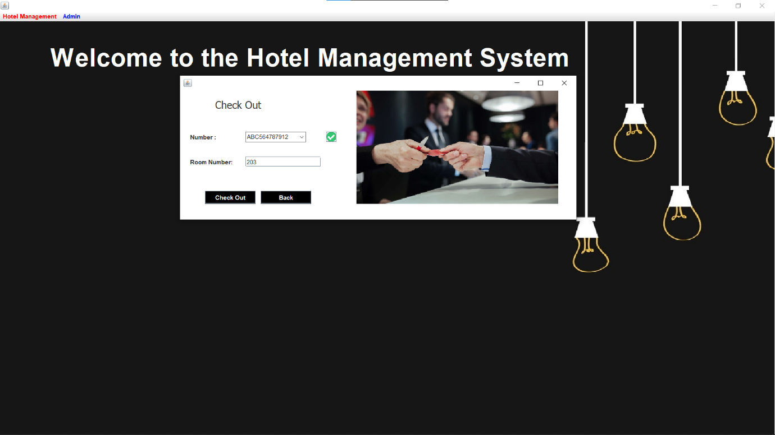

**F)MANAGER DETAILS**

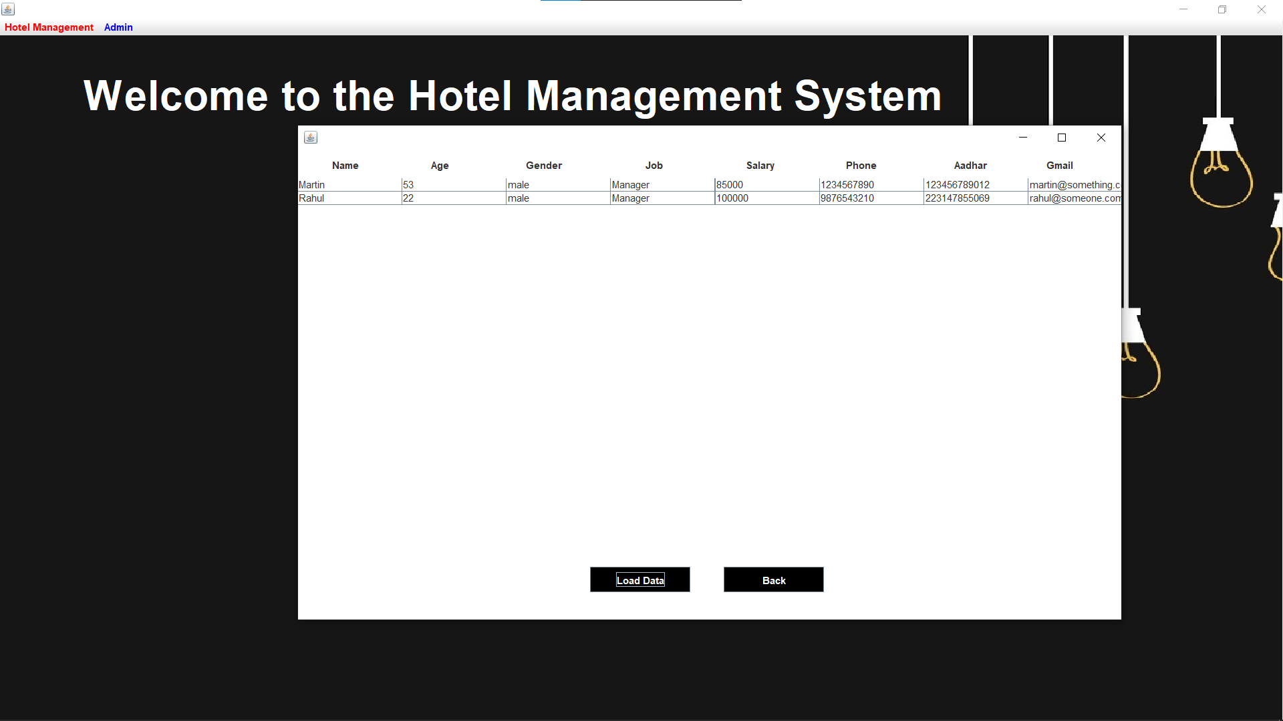

G)CUSTOMER DETAILS

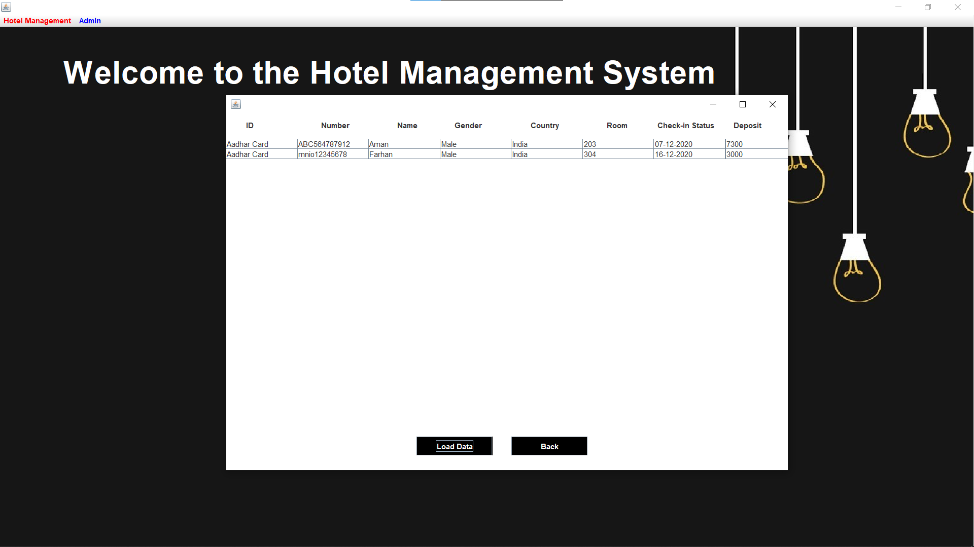

**H)EMPLOYEE DETAILS**

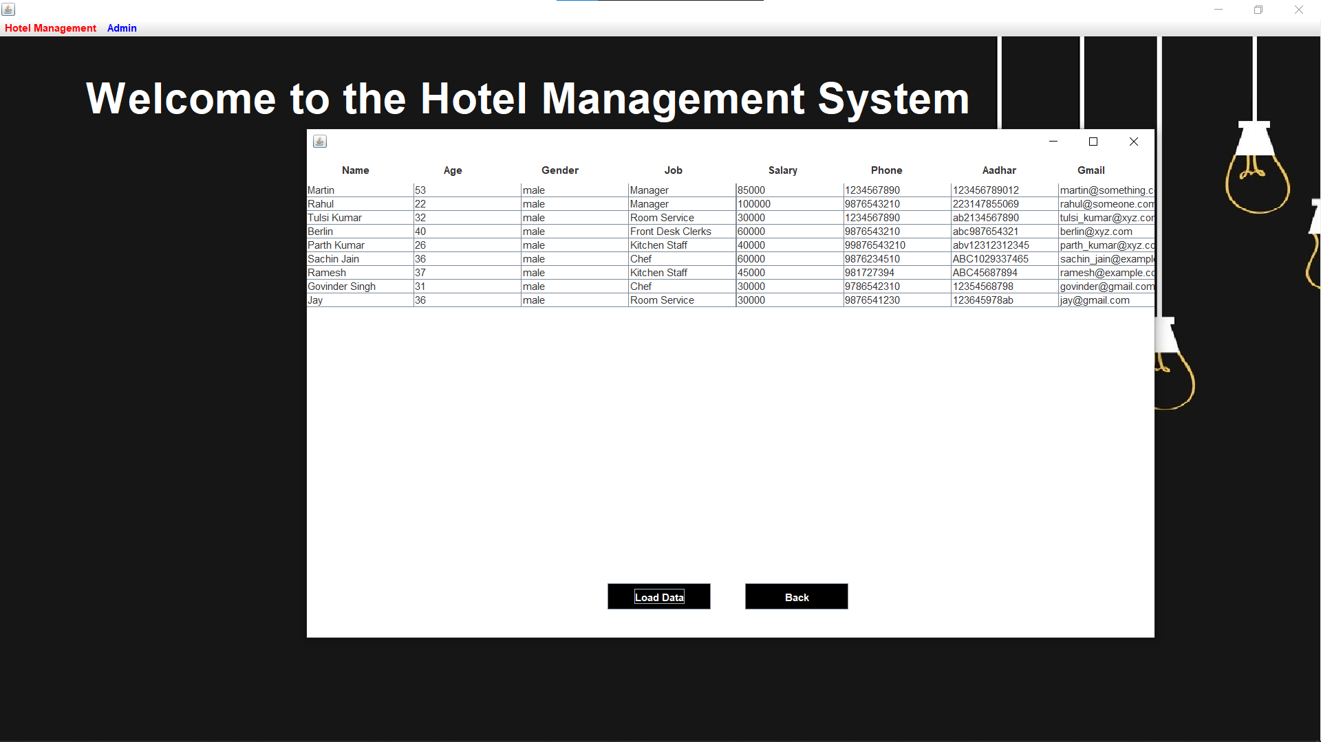

**I)DEPARTMENT DETAILS**

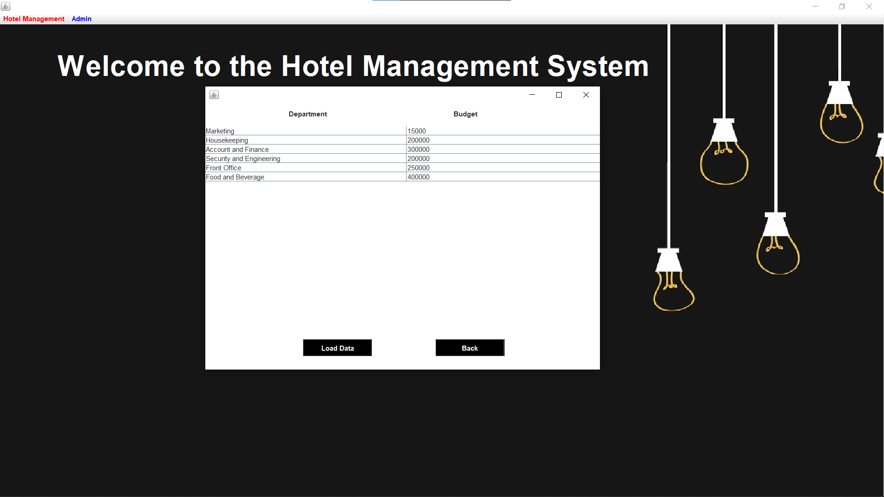

**J)ROOM STATUS**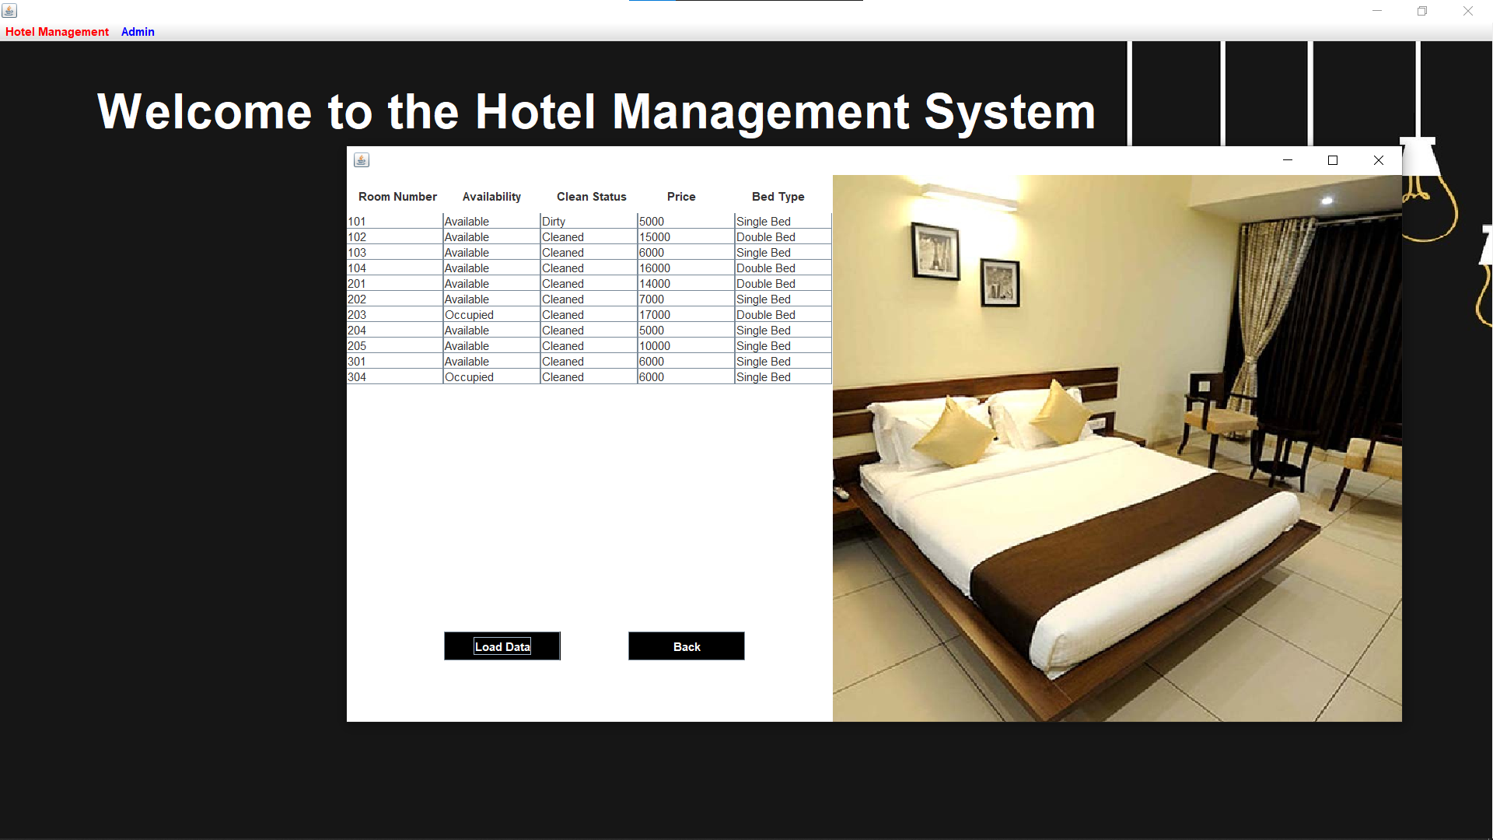

**K) NEW CUSTOMER DETAILS**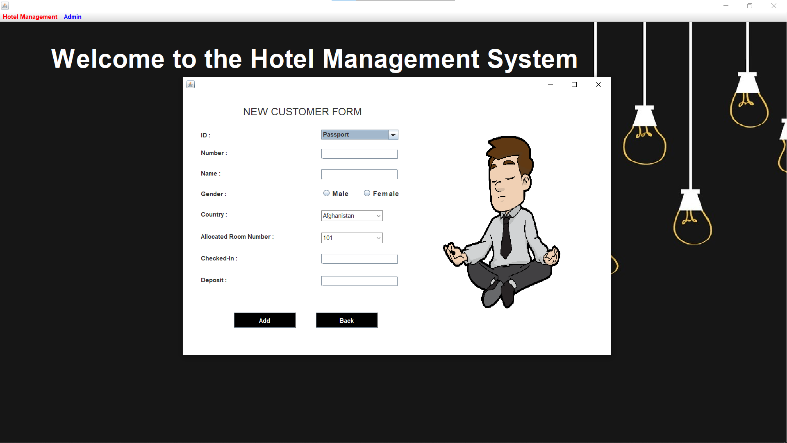

**L)RECEPTION FORM**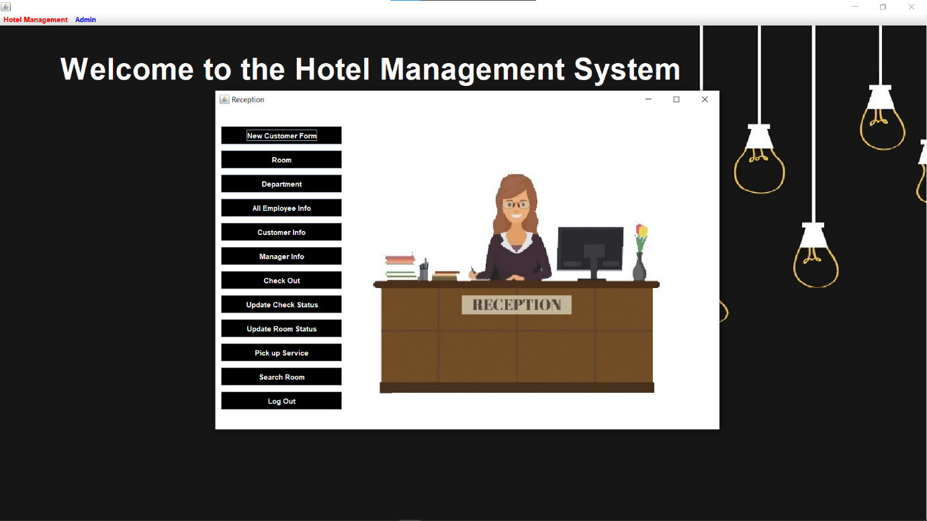

**M)DRIVER DETAILS**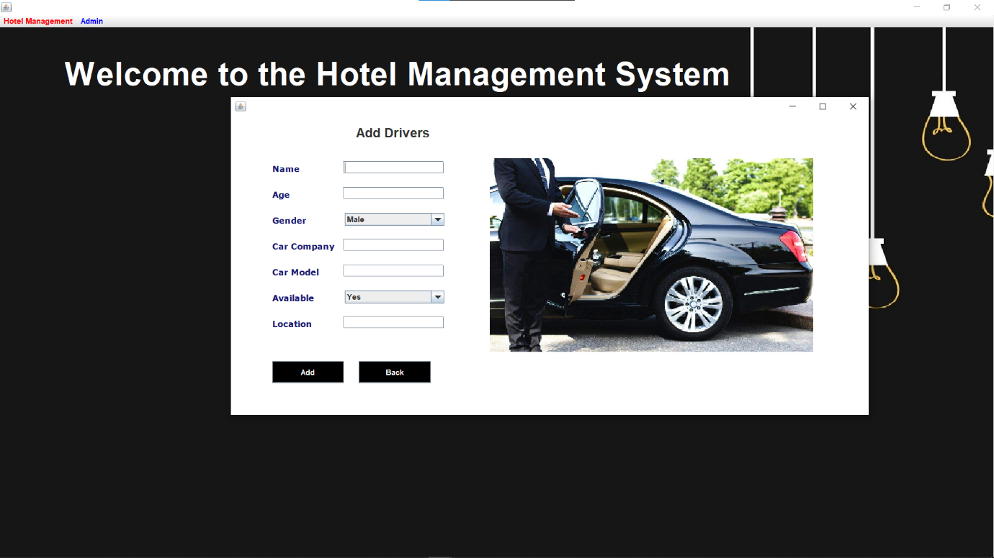

**O)ADD ROOM DETAILS**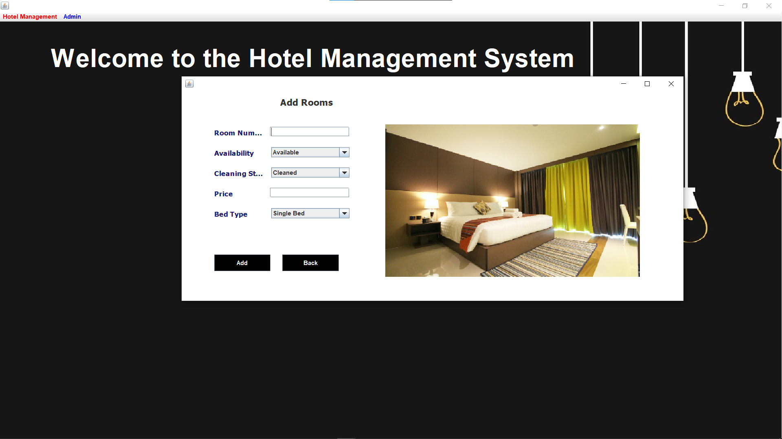

**P)SEARCH FOR ROOMS** 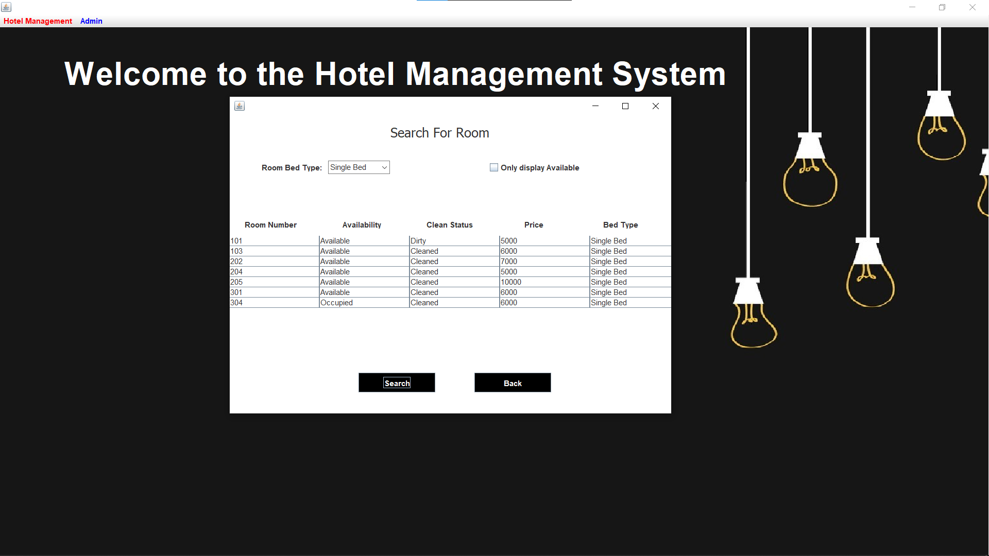

**Q)PICK UP SERVICE**